Modou Intelligent Manufacturing User Manual
- Enter the interface and select "en" in the top right corner to switch to the English interface. Select a theme scene in the dialog box (e.g., Aircraft Skin Processing), then send "hi" in the dialog box to start the conversation.
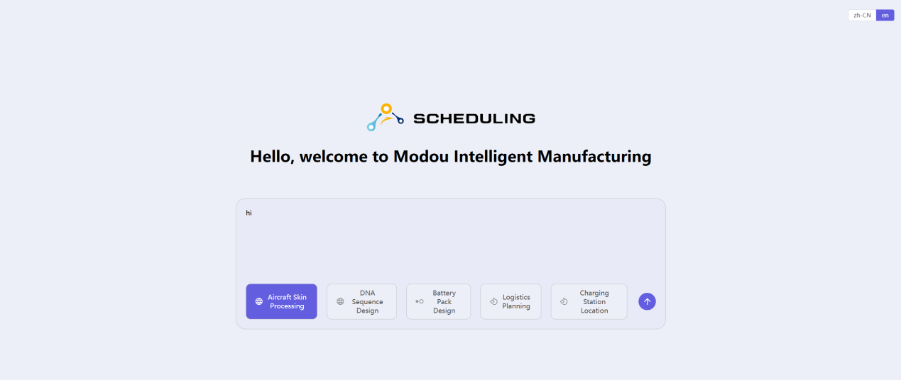
- After inputting the basic problem description, the AI will automatically perform constraint modeling for the basic problem. Click "Copy to Modeling" below the constraint description text box to populate the constraints into the model area on the right. If you only need to model and solve the basic problem, you can directly click the "Generate Code" button below the model area.
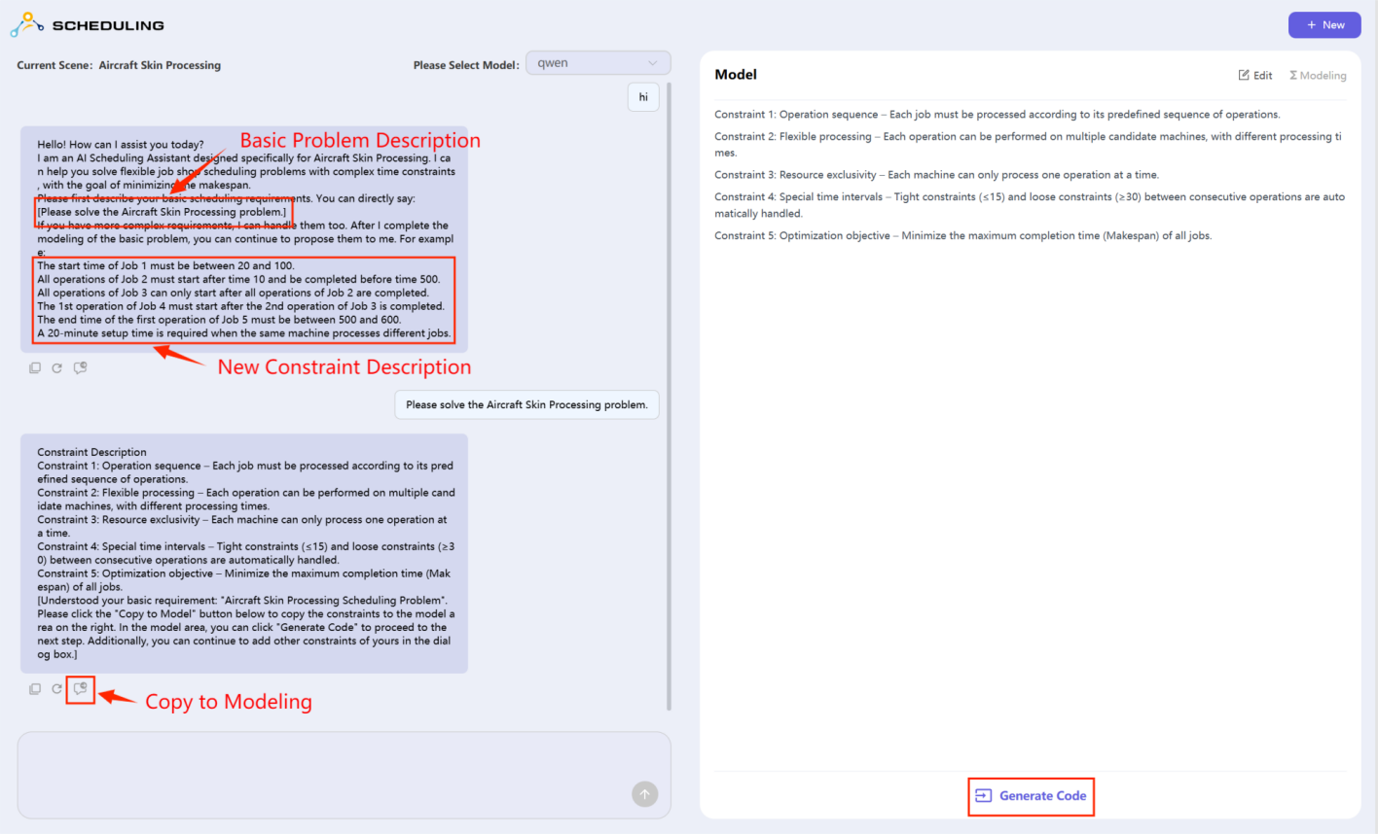
3、If you need to add new constraints, after completing the basic problem modeling, you can continue to input new constraint descriptions in the dialog box. You can input them one at a time or multiple at a time, and you can also use multiple rounds of conversation to input new constraints. Each time you finish inputting a new constraint, please click "Copy to Modeling" to insert it. The parameters provided in the examples can be changed, but please note that if they exceed the dataset limits or if there are conflicts between the new constraints, it may result in no solution for the model.
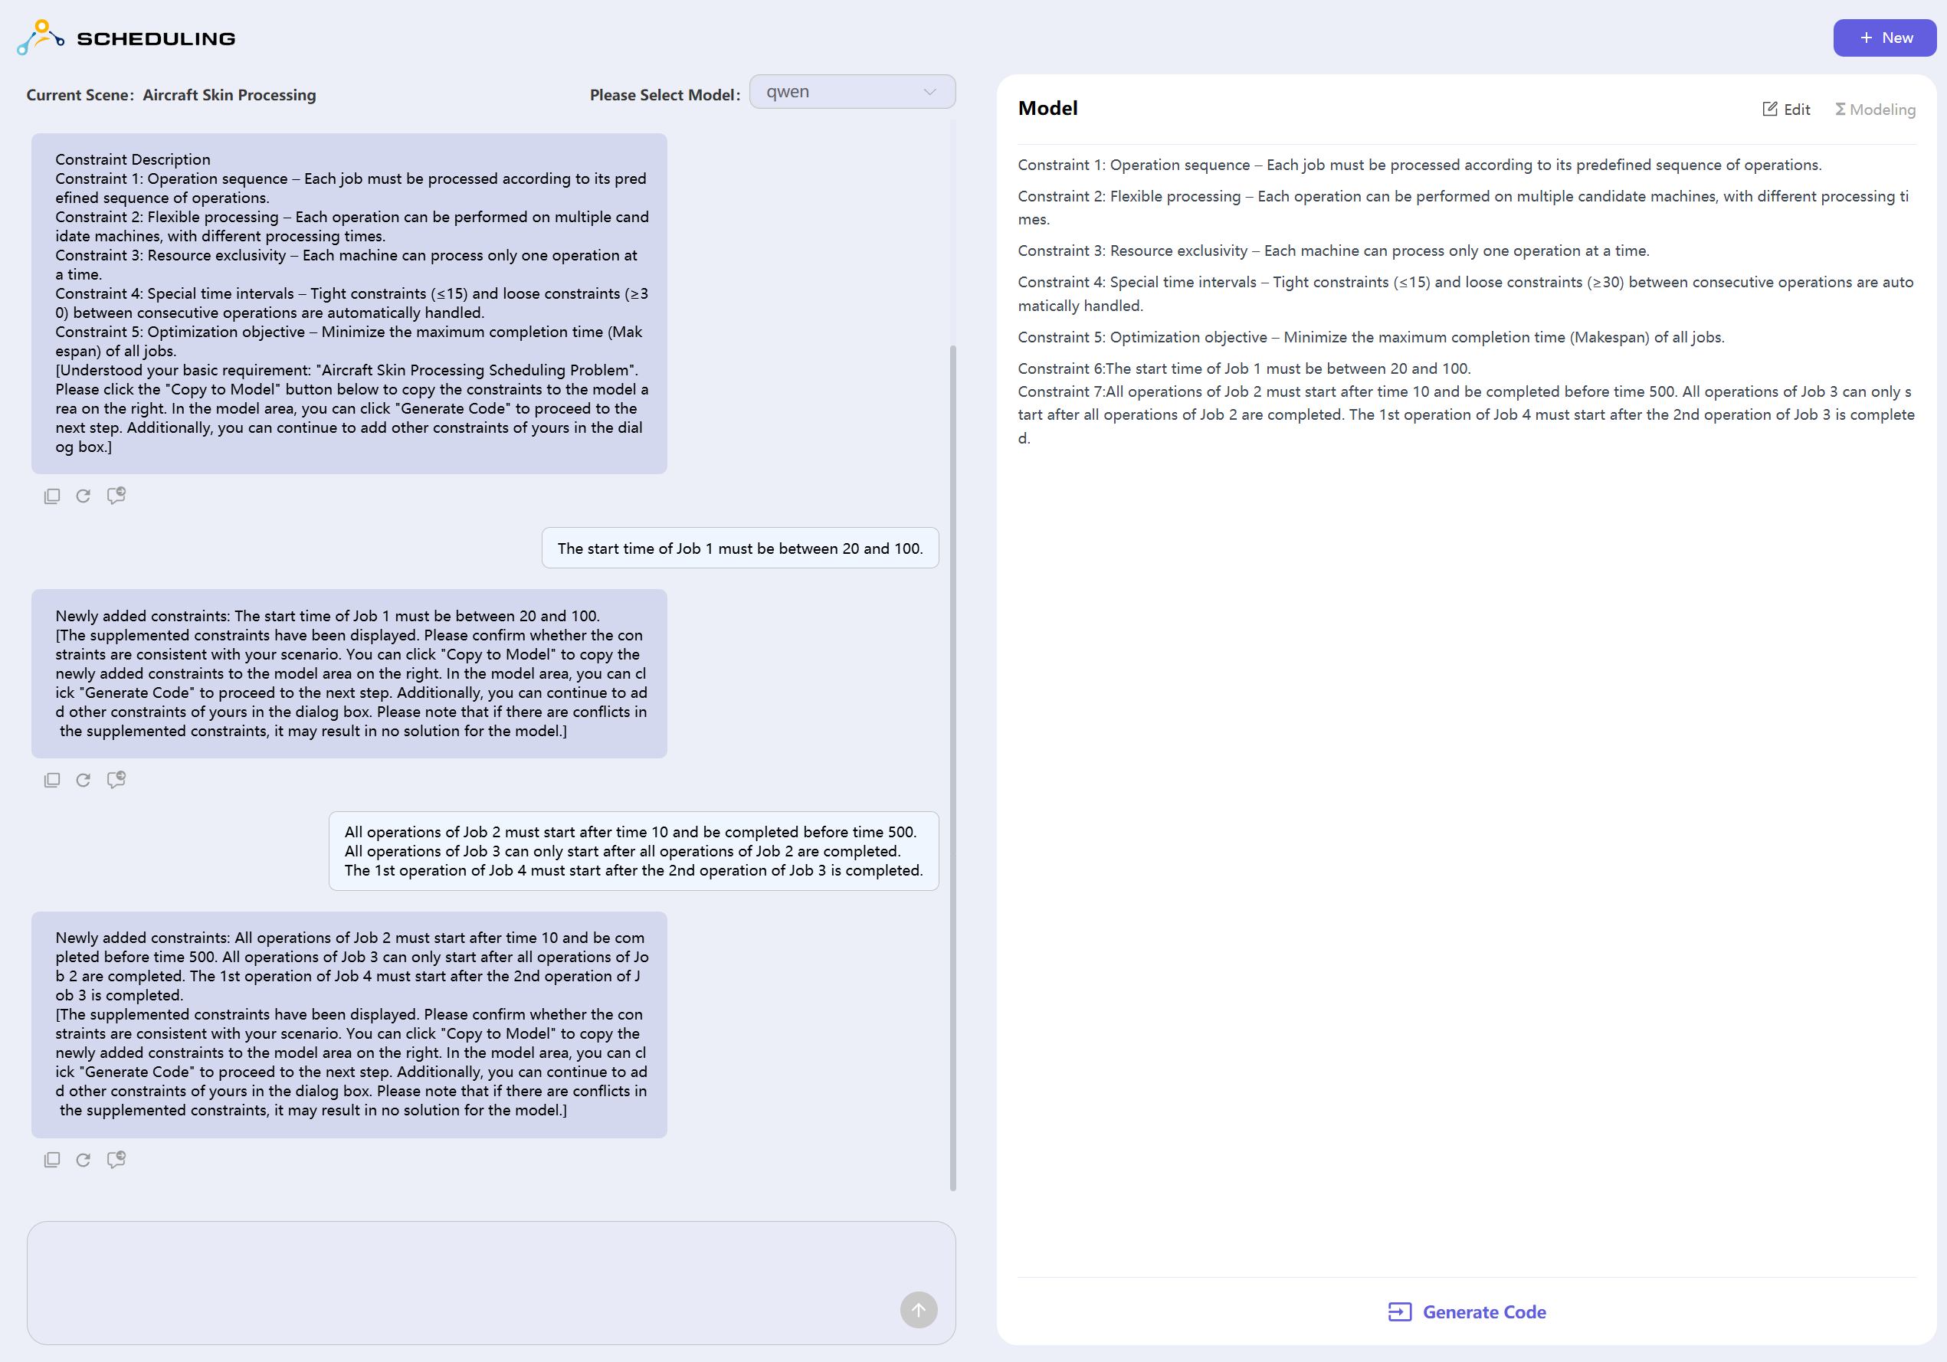

4、After you have finished inputting all new constraints, please click the "Generate Code" button below the model area. After the code is generated, click the "Example Dataset" button below to upload the example dataset, and then click "Run Solver" to complete the problem-solving. After the solution is complete, you will see the results in the area below.
